Queries

**Query 1 –**

**Display train names whose arrival time is between 6:00 AM & 9:00 AM ?**

**Code 1 –**

select trains5.Train_Name, Train_Arrival

from Trains5

inner join schedule5

on Trains5.Train_Number=Schedule5.Train_Number where Schedule5.Train_Arrival > '6:00' and Schedule5.Train_Arrival < '9:00'

**Output 1 –**

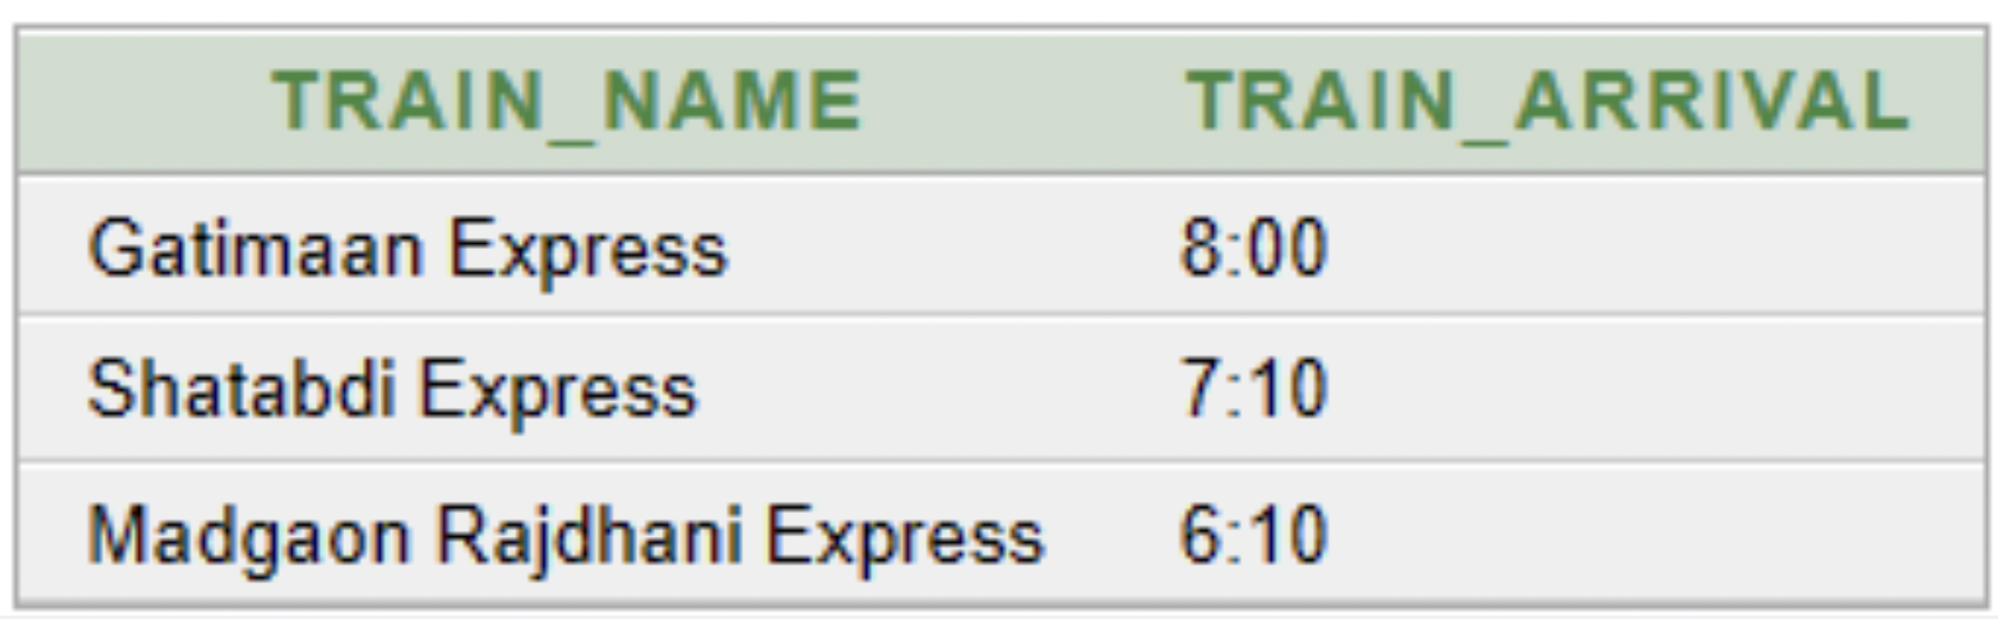

**Query 2 –**

**Display all the passenger names, PNR along with the train names they will be travelling from?**

**Code 2 –**

select Trains5.Train_Name, Tickets5.Name,Tickets5.PNR

from Trains5 inner join Tickets5

on Trains5.Train_Number=Tickets5.Train_Number

**Output 2 –**

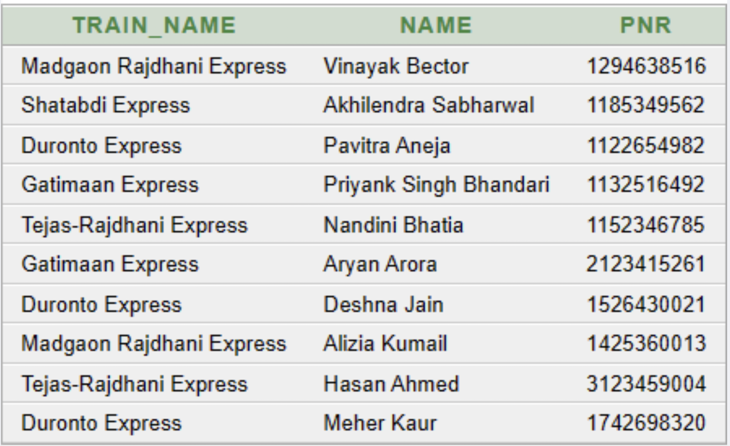

**Query 3 –**

**Display passenger name & PNR who are travelling from Madgaon Rajdhani Express?**

**Code 3 –**

select Trains5.Train_Name, Tickets5.Name, Tickets5.PNR

from Trains5 inner join Tickets5

on Trains5.Train_Number=Tickets5.Train_Number where Trains5.Train_Name='Madgaon Rajdhani Express'

**Output 3 –**

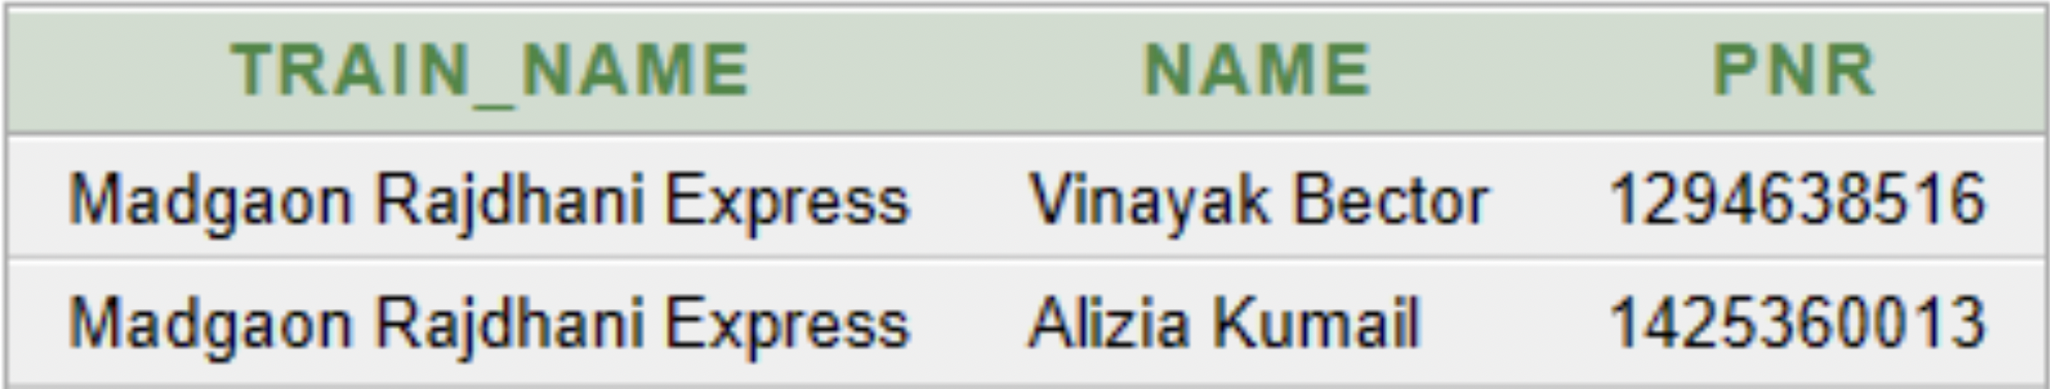

**Query 4—**

**Display the train name and train number which have Number of Coaches between 17 and 21 ?**

**Code 4 –**

select Train_Name,Train_Number

from Trains5

where No_Of_Coaches between 17 and 21

**Output 4 –**

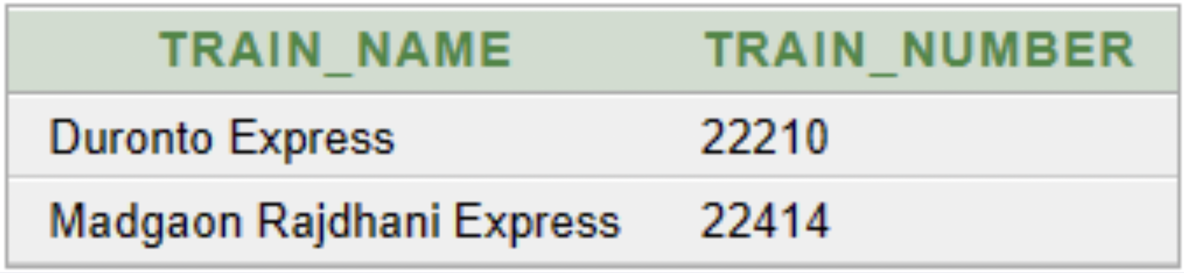

**Query 5—**

**Display the count of male passengers travelling from 1st to 3rd March,2023 ?**

**Code 5 –**

select count(Gender) as Male_passengers

from Passengers5 where Gender = 'Male'

**Output 5 –**

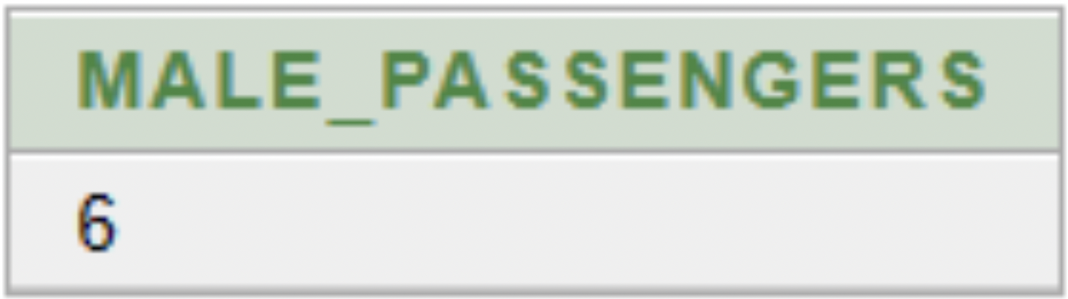

**Query 6 —**

**Display the passenger name, seat number and coach type whose starting station is New Delhi ?**

**Code 6 –**

select Name,Seat_Number,Coach_type

from Tickets5 where From_Station ='New Delhi'

**Output 6 –**

